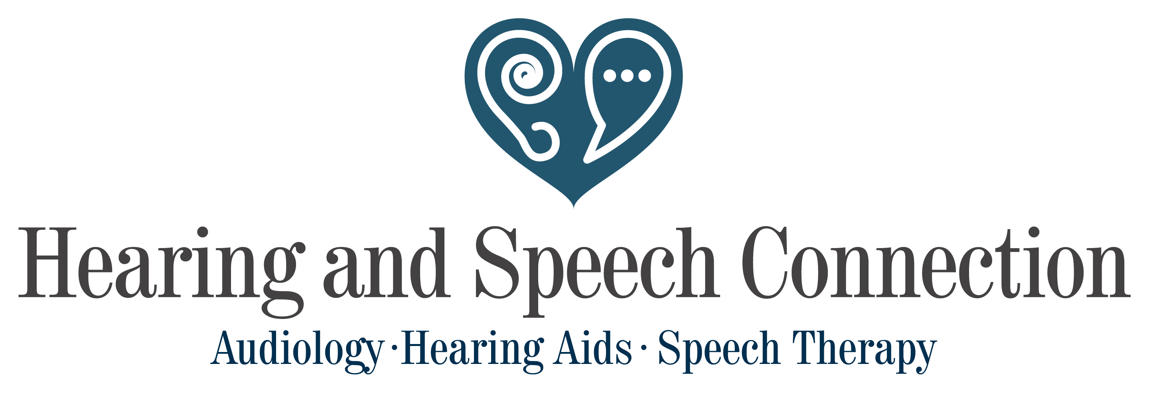

RECORDS RELEASE AND MARKETING AUTHORIZATION

I nearby authorize Hearing and Speech Connection to provide such services as evaluations, treatment, and other related services for my overall hearing and speech health as deemed necessary. I understand that if insurance, including Medicare and Medicaid, does not cover the cost of said services, that I will be responsible for the payment of such.

I nearby authorize the release of all pertinent information including diagnosis, examination records, and treatment records to my authorized medical and dental professionals. These records will be held in strict confidence and will not be available to unauthorized persons, as outlined by the Health Insurance Portability and Accountability Act (HIPPA) and explained in the Hearing and Speech Connection “Notice of Privacy Practices” document.

_____ I consent

_____ I do not consent

I understand that my personal information is private and that I have the right to prevent such information from being used for marketing purposes as outlined in the “Notice of Privacy Practices.” I further acknowledge that I am free to change my preference regarding whether or not to receive marketing materials at any time.

I understand that photos, videos, testimonials, and case studies of patients can be used for educational and marketing purposes. By checking the indicated line below, I give Hearing and Speech Connection permission to the above-mentioned information for these purposes. All steps will be taken by Hearing and Speech Connection to maintain the privacy and anonymity of patients in marketing and educational activities. All materials gathered by Hearing and Speech Connection employees are property of Hearing and Speech Connection, and patients are not entitled to compensation of any kind. I also understand that I am able to revoke this permission in writing at any time, except in actions already taken by Hearing and Speech Connection.

_____ I consent

_____ I do not consent

I have read and understood the above information and also acknowledge that I have had an opportunity to view and/or receive a copy of the “Notices of Privacy Practices.”

_____________________________________________ ___________________________

Signature Date

BILLINGS

2625 Grand Ave, Billings MT 59102

406-969-2770

MILES CITY

2600 Wilson St, Miles City MT 59301

406-233-4327

hascmt.com/speech

GLENDIVE

202 Prospect Dr. Glendive MT 59330

406-382-3220